ScoringIndicators model 2

COURSENAME: MECHANICAL ENGINEERING

COURSECODE: 3035 QID:

QNo | ScoringIndicators | Splitscore | SubTotal | Totalscore
 | PARTA |  |  | 9
I.1 | Density of fluid / density of water | 1 | 1
I.2 | Mass density = weight density/acceleration due to gravity | 1 | 1
I.3 | Type of flow in which fluid particle do not flow in stream line and rotate about its axis | 1 | 1
I.4 | “The flow must be steady  The flow must be incompressible | 1 | 1
I.5 | Kaplan turbine | 1 | 1
I.6 | Speed of a geometrically similar turbine | 1 | 1
I.7 | 2 stroke engine | 1 | 1
I.8 | Petrol and diesel engine , 2 stroke and 4 stroke engine | 1 | 1
I.9 | Petrol | 1 | 1
 | PARTB |  |  | 24
II.1 | - Specific gravity= density of given fluid/density of standard fluid  - Dynamic viscosity : resistance to flow  - Absolute pressure = atmospheric pressure+ gauge pressure | 1  1  1 | 3
II.2 | P = p g h  = 0.4*1000 * 9.81 * 40  = 156960 | 1  2 | 3
II.3 | As area increases velocity decreases  As area decreases velocity increases  A1V1=A2V2 | 1  1  1 | 3
II.4 | 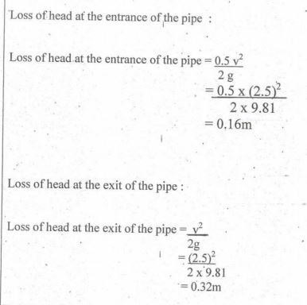 | 1  1  1 | 3
II.5 | WATERPOWER.  Ability to transform kinetic energy of water into mechanical energy  BRAKEPOWER  Power available at the shaft of turbine to power delivered by the water of runner is known as brake power | 3 | 3
II.6 | 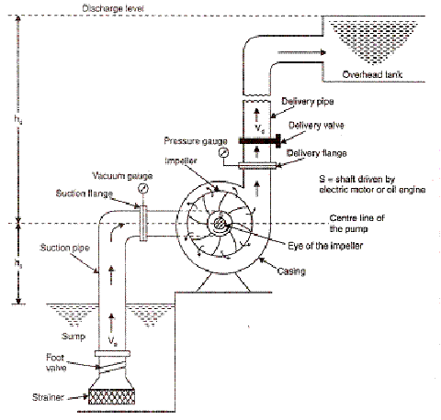 | 3 | 3
II.7 | - Impeller. An impeller is a rotor used to increase the kinetic energy of the flow.  - Casing (Volute). The casing contains the liquid and acts as a pressure containment vessel that directs the liquid flow in and out of the centrifugal pump.  - Shaft (Rotor). The impeller is mounted on a shaft. A shaft is a mechanical component for transmitting torque from the motor to the impeller.  - Shaft sealing. Centrifugal pumps are provided with packing rings or mechanical seal, which helps prevent the leakage of the pumped liquid.  - Bearings. Bearings constrain the relative motion of the shaft (rotor) and reduce friction between the rotating shaft and the stator. | 0.5*6 | 3
II.8 | A high pressure fire tubeboiler^{[1]} (also spelled water-tube and water tube) is a type of boiler in which water circulates in tubes heated externally by the fire. Fuel is burned inside the furnace, creating hot gas which boils water in the steam-generating tubes. In smaller boilers, additional generating tubes are separate in the furnace, while larger utility boilers rely on the water-filled tubes that make up the walls of the furnace to generate steam.  The heated water/steam mixture then rises into the steam drum. Here, saturated steam is drawn off the top of the drum. In some services, the steam passes through tubes in the hot gas path, (a superheater) to become superheated. Superheated steam is defined as steam that is heated above the boiling point at a given pressure. Superheated steam is a dry gas and therefore is typically used to drive turbines, since water droplets can severely damage turbine blades.  Saturated water at the bottom of the steam drum returns to the lower drum via large-bore 'downcomer tubes', where it pre-heats the feedwater supply. (In large utility boilers, the feedwater is supplied to the steam drum and the downcomers supply water to the bottom of the waterwalls). To increase economy of the boiler, exhaust gases are also used to pre-heat combustion air blown into the burners, and to warm the feedwater supply in an economizer. Such watertube boilers in thermal power stations are also called steam generating units. | 3 | 3
II.9 | A steam turbine is a machine that extracts thermal energy from pressurized steam and uses it to do mechanical work on a rotating output shaft. Its modern manifestation was invented by Charles Parsons in 1884.^{[1][2]} Fabrication of a modern steam turbine involves advanced metalwork to form high-grade steel alloys into precision parts using technologies that first became available in the 20th century; continued advances in durability and efficiency of steam turbines remains central to the energy economics of the 21st century.  The steam turbine is a form of heat engine that derives much of its improvement in thermodynamic efficiency from the use of multiple stages in the expansion of the steam, which results in a closer approach to the ideal reversible expansion process.  Because the turbine generates rotary motion, it can be coupled to a generator to harness its motion into electricity. Such turbogenerators are the core of thermal power stations which can be fueled by fossil fuels, nuclear fuels, geothermal, or solar energy. About 85% of all electricity generation in the United States in the year 2014 was by use of steam turbines | 3 | 3

II.10 | 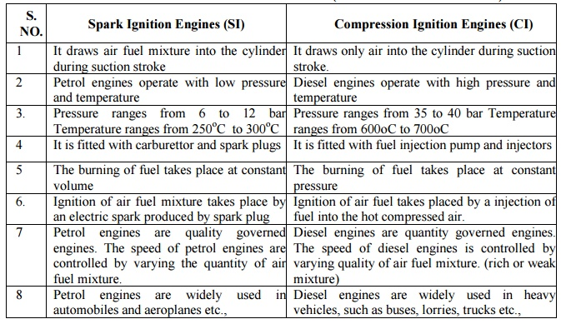 | 3 | 3
 | PARTC |  |  | 42
 | Manometer is a device that measures fluid pressure. Based on various criteria, manometers are classified into different types. They are:  - U-Tube Manometer  - Enlarged-Leg Manometer  - Well-Type Manometer  - Inclined-Tube Manometer  U-Tube Manometer  U-tube manometer features a vertical or inclined U-tube column that is filled with a reference liquid (mercury) to display the pressure level. When the columns of the device are exposed to the atmosphere, the levels of liquid in the limbs are equal and this indicates the atmospheric pressure. When one of the columns is connected to the pressure vessel, there will be a difference in the level of the liquid in the limbs, which signifies the pressure of the liquid in the vessel.A simple U-tube manometer is shown in the figure below. This type of manometer includes no moving parts and requires no calibration.  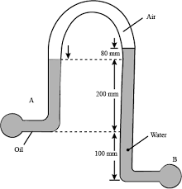 | 2  2  2  1 | 7
 | 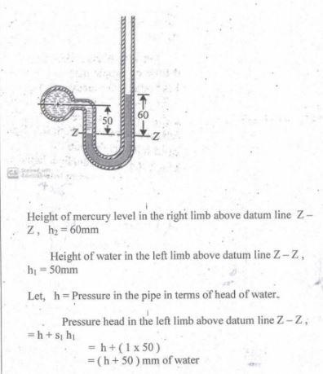  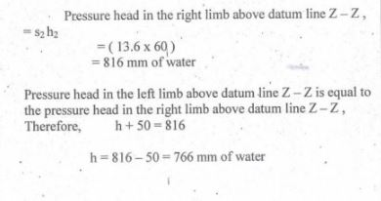 | 2  2  1  2 | 7
- III. 3 | 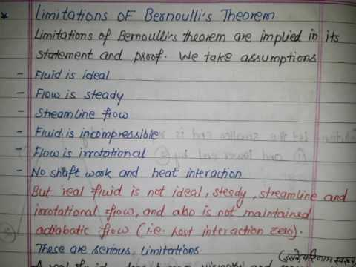  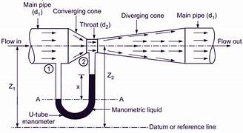 | 3  3  1 | 7
- III. 4 | Chezy's Formula for Loss of Head due to Frictionh_{f} / L = I i.e. loss of head per unit length of pipe. This is known as Chezy's formula. This is the required relation between Darcy's coefficient and Chezy's Constant.  Darcy's law says that the discharge rate q is proportional to the gradient in hydrauolic head and the hydraulic conductivity (q = Q/A = -K*dh/dl). Definitions of aquifers, aquitards, and aquicludes and how hydraulic conductivity relates to geology | 3  4 | 7
- III. 5 | 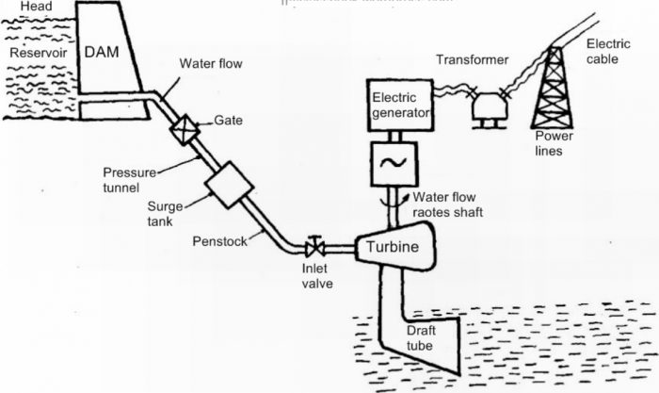  - Nozzle and Flow Regulating Arrangement  - Runner and Buckets  - Casing  - Braking Jet  The working of Pelton turbine is as follows:  - The water is transferred from the high head source through a long conduit called Penstock.  - Nozzle arrangement at the end of penstock helps the water to accelerate and it flows out as a high speed jet with high velocity and discharge at atmosphericpressure | 4  3 | 7
- III. 6 | Francis Turbine is a combination of both impulse and reaction turbine, where the blades rotate using both reaction and impulse force of water flowing through them producing electricity more efficiently. Francis turbine is used for the production of electricity in hydro power stations. Majorly there are 2 turbines flow patterns on which they work, namely radial and axial flow concepts. An American civil engineer by name, James B. Francis in Lowell, Massachusetts comes up with an idea of combining both impulse and reaction turbine where water enters the turbine radically and exits axially.  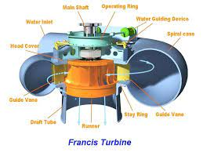 | 4  3 | 7
- III. 7 | Air vessel in reciprocating pump  An air vessel is basically a closed chamber from its one side which will have compressed air in the top and water or liquid at the bottom of the chamber. At the base of the chamber, there will be an opening through which liquid may flow in to the air vessel or out from the air vessel.  Air vessels will be installed at suction side and delivery side of the reciprocating pump as displayed here in following figure.  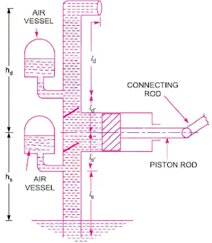  Air vessel is installed with reciprocating pump in order to secure the following task.  - To secure the continuous flow of liquid with uniform rate of flow  - To save the suction and discharge pipe  - To save the considerable amount of work in overcoming the frictional resistance in the suction and delivery pipes  - To run the reciprocating pump at a high speed without separation | 4  3 | 7
- III. 8 | 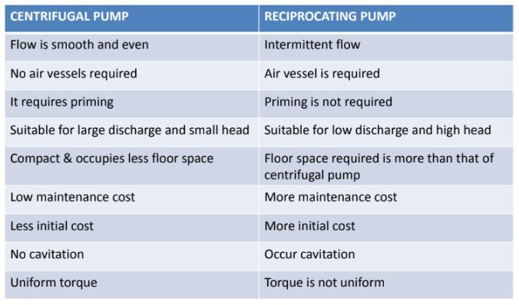 | 7*1 | 7
- III. 9 | 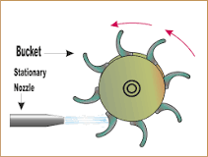  WORKING PRINCIPLE OF IMPULSE STEAM TURBINE  In Impulse Steam Turbine, there are some fixed nozzles and moving blades are present on a disc mounted on a shaft. Moving blades are in symmetrical order. The steam enters the turbine casing with some pressure. After that, it passes through one or more no. of fixed nozzles into the turbine. The relative velocity of steam at the outlet of the moving blades is same as the inlet to the blades. During Expansion, steam's pressure falls. Due to high-pressure drop in the nozzles the velocity of steam increases  In a reaction turbine, nozzles will move on bearing in the opposite direction of the steam flow and the pressure is not constant in this turbine. That's why; a reaction force is always applied on the nozzles and tubes. In this turbine steam produces both impulsive and reactive force. So, the resultant force produces to the rotor is the vector sum of impulsive and reactive force and the reaction force is an unbalanced condition. Generally, this turbine is not used for commercial purpose. Due to this reactive force, it is called reaction turbine. | 4  3 | 7
- III. 10 | 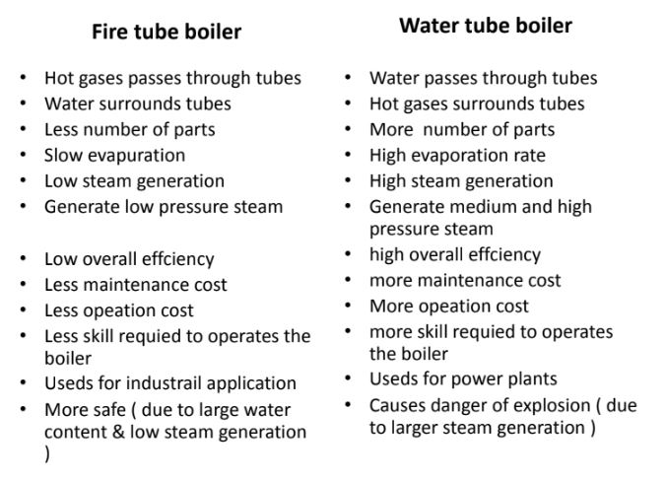 | 1*7 | 7
- III. 11 | Two stroke or Two cycle engine is an internal combustion (IC) engine, in  which four individual cycle of operation is completed by each revolution of  the crankshaft or two individual strokes of piston  The four separate strokes are listed and described below ;  1. Suction – Piston at TDC position , inlet port is opened , air+fuel mixture/ fresh air enters into crankcase through inlet port , exhaust port an transfer port is in closed position  2. Compression – air+fuel mixture/fresh air is compressed inside cylinder ,both transfer port and exhaust port closed  3. Power – at the end of compression charge ignites using sparkplug/fuel injector , piston starts moving from TDC to BDC  4. Exhuast – piston travels from BDC to TDC , inlet valve is closed , transfer port and exhaust port are opened , fresh charge enters into cylinder through transfer port and exhaust gases ejected out to atmosphere through outlet port  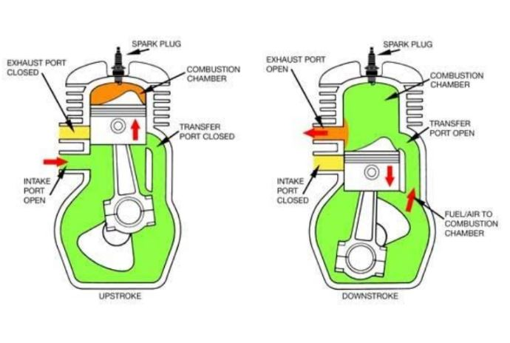 | 4  3 | 7
- III. 12 | 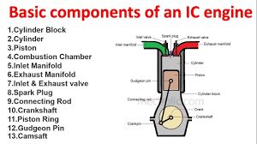 | 7*1 | 7

