DIPLOMA EXAMINATION IN ENGINEERING/TECHNOLOGY/ :MANAGEMENT/ COMMERCIAL PRACTICE, NOVEMBER- 2025

Construction management and safety engineering

Answer key

PART-A
(9 x 1 = 9 Marks)

1. | A group of persons united to achieve a common goal and defining the responsibilities and establishing the relationship with each other employed in the organization. | 1 | 1
2. | Line or military organization  Functional organization  Line and staff organization | 0.5x2 | 1
3. | An activity is a part of the project denoted by an arrow on the network.  • The tail of the arrow indicates the start of the activity whereas the head indicates the end of the activity.  •One and only one arrow is used to represent one activity of given duration. | 1 | 1
4. | In this type of chart, the time duration of an activity is represented by horizontal line.  • This chart mainly consists of two co-ordinate axes. One co-ordinate represents the name of the work, activity or job performed and the other represents the time elapsed. | 1 | 1
5. | - An agreement enforceable by law is called contract.  - A contract invariably follows a proposal from one party and its acceptance by the other. | 1 | 1
6. | The contractor is paid on cost plus percentage basis of work and in addition he receives a percentage plus or minus on savings or excesses effected against a prior agreed estimated by measuring the work on completion and valuing at prior agreed rates. | 1 | 1
7. | Materials management is the process of planning and controlling material flows.  • It includes planning and procuring materials, supplier evaluation and selection, purchasing, expenditure, shipping, receipt processes for materials (including quality control), warehousing and inventory, and materials distribution. | 1 | 1
8. | - Planning defect and effects in designing.  - Unsuitable time limits.  - Selecting incompetent contractors.  - Defective supervision of work. | 0.5x2 | 1
9. | - Previous safety record of a contractor is an important consideration in the pre qualifications of contractor.  - Safety is a cost item and no worth while programme can be developed without providing finds for it.  . | 0.5x2 | 1

PART-B
(8 x 3 = 24 Marks)

1. | 1. Minister  • Look after one or two engineering Departments  • One member from a state  2.Secretary  • Every dept. will have a secretary as IAS Officer on behalf of Govt.  • He is the administrative head who reports to the minister  3.Chief engineer  • Administrative head of the department.  • He manages to prepare annual budget estimation relating to works and administers the grants allotted.  4.Superintending engineer  • Responsible to the chief engineer.  • Exercises Financial control.  • Exercises execution of original and repair works.  • Inspects the work progress periodically. | 1x3 | 3
2. | - Line or military organization  - Functional organization  - Line and staff organization  Line or military organization  • Simplest type of organization  • The responsibility distributed from top to bottom.  Advantages  • Responsibilities at all levels are definite and fixed.  • It is simple to work and easily understood by the employees. | 1.5+1.5 | 3
3. | Principles of organization  Responsibility  Authority should be equal to responsibility. Each manager should have enough authority to accomplish the task.  Specialization  Effective organization must include Specialization. Precise division of work facilitates specification.  Personal ability  Organization structure must encourage management development programme and ensure optimum use of human resources.  Flexibility  It should be adaptable to changing circumstances. It should not be rigid or inelastic. | 3x1 | 3
4. | Class A: High value (70-80% of the total value of inventory), few items (10-20% of the items)  Class B: Medium value (15-20%) more items (20-30%)  Class C: Low value (5-10%), high quantity (50-60% ) | 1x3 | 3
5. | Cost slope is the increase in cost per unit of time saved by crashing.  Nt= Normal time  Nc= Normal cost  Ct= Crash time  Cc= Crash cost | 3 | 3
6. | - The Equipment must meet the requirement of the work, climate and working conditions.  - Size of Equipment  - Past Performance  - Operating Requirements  - Reliability of Equipment  - Economical Aspects  - Service Support  - • Use in Future Projects | 0.5x6 | 3
7. | • The tenders should be in the prescribed form which can be downloaded from site www.etenders.kerala.gov.in . • The tender fee should be submitted online. • The tender form without prescribed tender fee will be summarily rejected. • The cost of tender forms once paid will not be refunded. • There are 6 files which are mandatory for uploading a tender. • 1. Notice inviting tender (NIT) - PDF format. • 2. Tender document –PDF format. • 3. Agreement form – PDF format. • 4. e payment form – PDF format. • 5. Bill of quantity (BOQ) – Excel format. • 6. e tender data sheet – Word /PDF format | 7 | 7
8. | When the contract is awarded without calling tenders on the basis of negotiation only, it is called negotiated contract. It may be any form discussed above | 3 | 3
9. | - Loss of human life  - Temporary or permanent injuries to workers.  - Loss or damage of materials and equipments.  - Loss of time in completion as work.  - Loss due to workmen compensation insurance and cost involved is redoing the work. | 3 | 3
10. | - The laws relating to Wages i.e. The Payment of Wages Act, 1936  - The Minimum Wages Act, 1948, These laws are applicable for the construction workers employed in the organized sector.  - 5. Laws relating to Equity and Empowerment of Women are The Maternity Benefits Act, 1961,  - The Equal Remuneration Act, 1976.  - The Laws Affecting Construction Companies in India. The Labour Code, 1995.  - The Contract Labour (Regulation and Abolition) Act 1988. The Factories Act 1993. Contract Law in India. | 0.5x6 | 3

PART-C

(6 x 7 = 42 Marks)

III. | Nature of the project :  Describes the type of project  Construction methods: Construction can be either cast in-situ or by precast elements. If it is to be of precast elements, then provision for casting yard should be included in the job layout.  Availability of resources: Various types of resources are used in executing a project such as labor, plant and equipment material etc.  Medical Facilities: If it is a big and complex type of project then it is desirable that a field medical facility.  Contractors and Site engineer’s offices: These should be located preferably in a noise free area for better co-ordination.  OR  site layout.  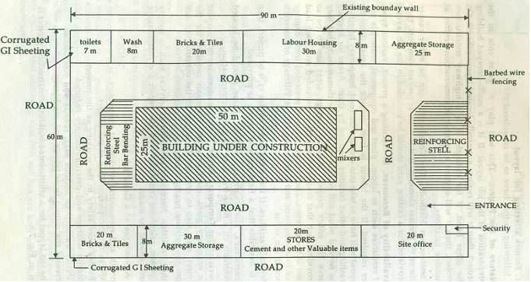 | 7 | 7
IV.
 |  | 7 | 7
V. | 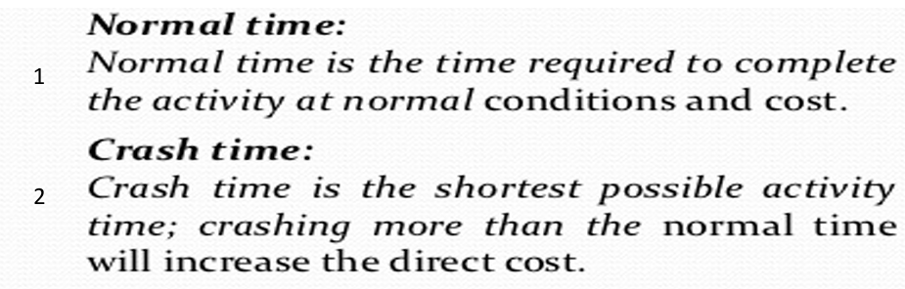  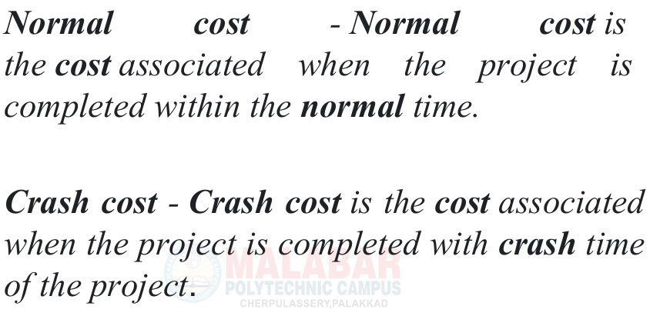  OR  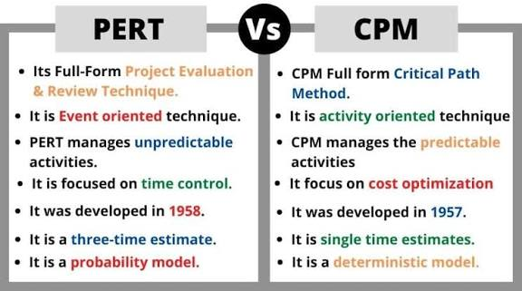 | 2+2+2+1 | 7
VI. |  | 3.5x2
VII. | Bull dozer • Angle dozer • Excavator • Power shovel • Forklift • Tower crane • Gantry crane • Slip form paver • Grader  Bull dozer  • Bull dozers are machines designed primarily for cutting and pushing the material over relatively short distances.  • Consist of tractor with a front mounted blade, controlled by hydraulic cylinders  Angle dozer  • When the cutting blade of bulldozer is set at an angle with the direction of travel is called angle dozer.  • Angle Dozers work best handling broken and granular materials, soils, and gravel  OR  The parties and arbitrators meet in person to conduct the hearing in which the parties present arguments and evidence in support of their respective cases.  • After the conclusion of the hearing, the arbitrators deliberate the facts of the case and render a written decision called an award.  • Industrial disputes can be resolved by way of adjudication i.e. settlement of an industrial dispute by labour court or industrial tribunal.  • The appropriate government may refer a dispute to adjudication depending on the failure of conciliation proceedings. | 1+3+3 | 7
VIII. |  | 7 | 7
 | - Training must be provided to employees who will use fire protection equipment.  - Portable fire extinguishers are required on all job sites.  - Fire emergency reporting numbers should be prominently posted.  - Install Smoke Alarms.  - Plan Your Escape From Fire.  - Keep an Eye on Smokers.  OR  - Supervising and instructing the construction team as well as subcontractors.  - Educating site workers on construction safety regulations and accident protocol.  - Enforcing site safety rules to minimize work-related accidents and injuries.  - Handling site accidents in accordance with established accident protocol.  - Supervisors are responsible for maintaining a safe work environment.  - They must routinely inspect the workplace, identify unsafe actions or conditions, and take immediate corrective action.  - Should an issue be beyond their authority or ability to rectify, they must escalate it to the Departmental Manager. | 7 | 7
IX.
 |  | 7 | 7
X.
 | Construction disputes may be categorized as follows:  1. Contractor’s claims against client.  2. Client's claims against the contractor.  Claims of contractor against client.  • Claims for refund of money wrongly deducted  • Claims for extra amount on petty grounds.  • Claims for compensation for losses suffered by the contractor due to the delay in supply of construction materials, delay in sanction etc.  • Interest on delayed payments.  Claims of client against contractor.  • Claims for defective work done by the contractor.  • Claims for over payments made to the contractor.  • Claims for liquidated damages for delays caused by contractor in completing the work.  • Interest on amounts claimed by the client.  • Other compensation claims for delays caused by the contractor.  OR  - Always wash your hands after using any unsafe material.  - Store materials properly, as directed on their labels.  - Flammable chemicals should be stored in a cool, dry place away from heat and sunlight.  - Some chemicals like acids must be stored separately from each other.  - Choose paints, solvents and other building materials which are less hazardous to the environment and personnel, not just based on their cost and durability.  - limiting the number of people near the work.  - Suitable face masks should be supplied for the use of workers when the paint is applied. | 3.5x2 | 7
XI.
 |  | 1x7 | 7
XII.
XIII. | - Direction of arrow should be from left to right  - No event can be completed before the activity which precedes is completed  - No activity can be started until the event which precedes it has been reached  - No set of activities can form a circular loop.  - Avoid crossing the activities as much as possible  - All activities should be straight Avoid denting activity  OR  Vital  • Vital items are those which are very critical for production. • If these are out of stock, it will lead to immediate production stoppage and heavy production loss.  Essential  • Essential items are those which are very important. • They are essential but their absence would not do much harm in production  Desirable items  are those which are required for production but factory can manage without them for some time, say, a week or even more because they have some substitutes | 1x7 | 7
XIV. |  | 2+2+3 | 7

